**JavaScript Exercise**

**Overview:**

This assignment was broken into two parts

* **Project 1** - Add functionality to a pre-written application
  + Add a data-entry feature to the rawMVC app that would add a list item by pushing the enter key
* **Project 1b** - Create a JavaScript drag-and-drop Quiz Game
  + A game that has terms that needs to be matched to the definition
  + The terms must be able to be picked up, dragged, and dropped on the correct definition
  + When the term is on the correct definition, the term element will change to green
  + Game would be scored according to the number of correct matches
  + Option to “Try Again” after the game is over

**Constraints:**

* Browser support for Google Chrome or Mozilla Firefox
* No frameworks such as BackBone or libraries such as jQuery or templating tools
* Comments and/or descriptions in the code that explains the rationality and logic behind the design decisions

**Extra credit:**

* Project 3 (The original first project).
* For Project 1b, make the terms unavailable after a round has been completed.

**Background:**

I am a recent college graduate with no prior experience in programming. I graduated from Jackson State University in December of 2018. Most of my experience is with Java and Python. I have no experience in Full-Stack Java development. I also have no experience with JavaScript or HTML.

Research:

* I had to research JavaScript the most. I needed to understand how it is written. I understand that it is not Java but similar.
* I had to research HTML tags and learn how to link the elements to its assigned JavaScript functions.
  + The first thing I needed to learn was simply how to make “things” appear on a page.
  + Next, I had to learn the difference between a class and an Id tag and how they could be used
  + Understanding what could be done with a <div> was crucial. After I had a decent understanding of this, I felt I could really begin with adding functionality to the HTML elements.
* I had to research JSON files and learn how they are formatted and how to pull the information contained in it to the application.
* I had to do a lot of research on MVC architecture. I needed to understand how it is formatted so I could have an understanding where to look for certain functions within a pre-written application.
* I had to research how to key bind a particular function.
* I had to learn how to use Google Chrome’s dev tool.

**Project 1:**

I was able to complete project 1 with some help from my peers. I had to research MVC architecture to understand what it was and how it is used. I needed to learn how to follow functions so that I could find the section I needed to complete a task. After I did this, I was able to add the needed code to give it the additional functionality of adding data to a list by pushing the “Enter” key.

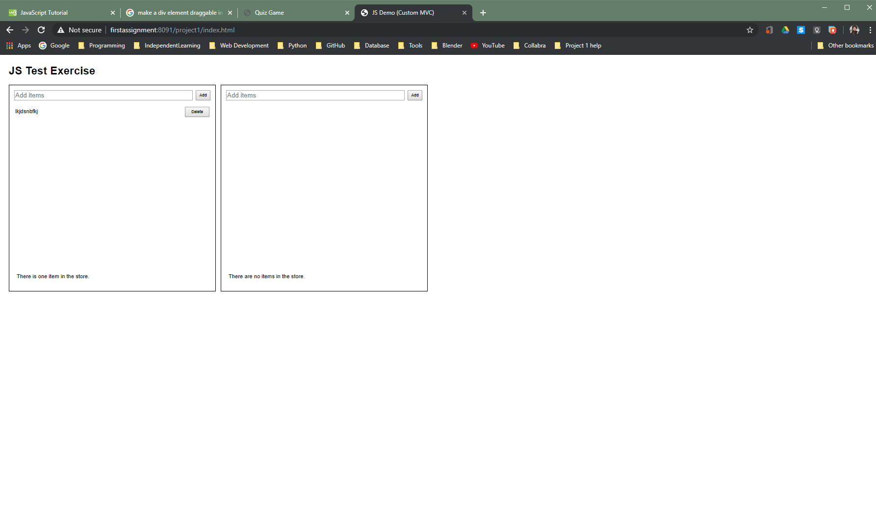

I did accomplish the main goal of this project. I would like to say I figured it out on my own but that is not the case. However, I was able to learn about a few points that I will need to know in my pursuit to becoming a Full-Stack Java developer.

**Project 2:**

The goal for project 2 was to build a web app that was a drag-and-drop matching game. This project was difficult for me. Going in, I had no clue where to begin. However, with the help of my peers, I started to gain more understanding over time. I had to use the HTML code that was provided as a starting point. From there, I was able to give it some functionality. I was able to:

1. Make the HTML “Term” <divs> draggable and droppable.
2. I created a timer that worked in my POC but was unable to implement it in my application.
3. I was able to change some small elements like color and put elements in different areas.
4. The rest of my app’s creation depended on my ability to link functionality to a HTML button, but I was unable to accomplish this goal. I believe that some of my issues revolves around my computer. In my case, the HTML id or class would be correctly matched, and the files correctly linked to each other but when refreshed, the changes would not be reflected.

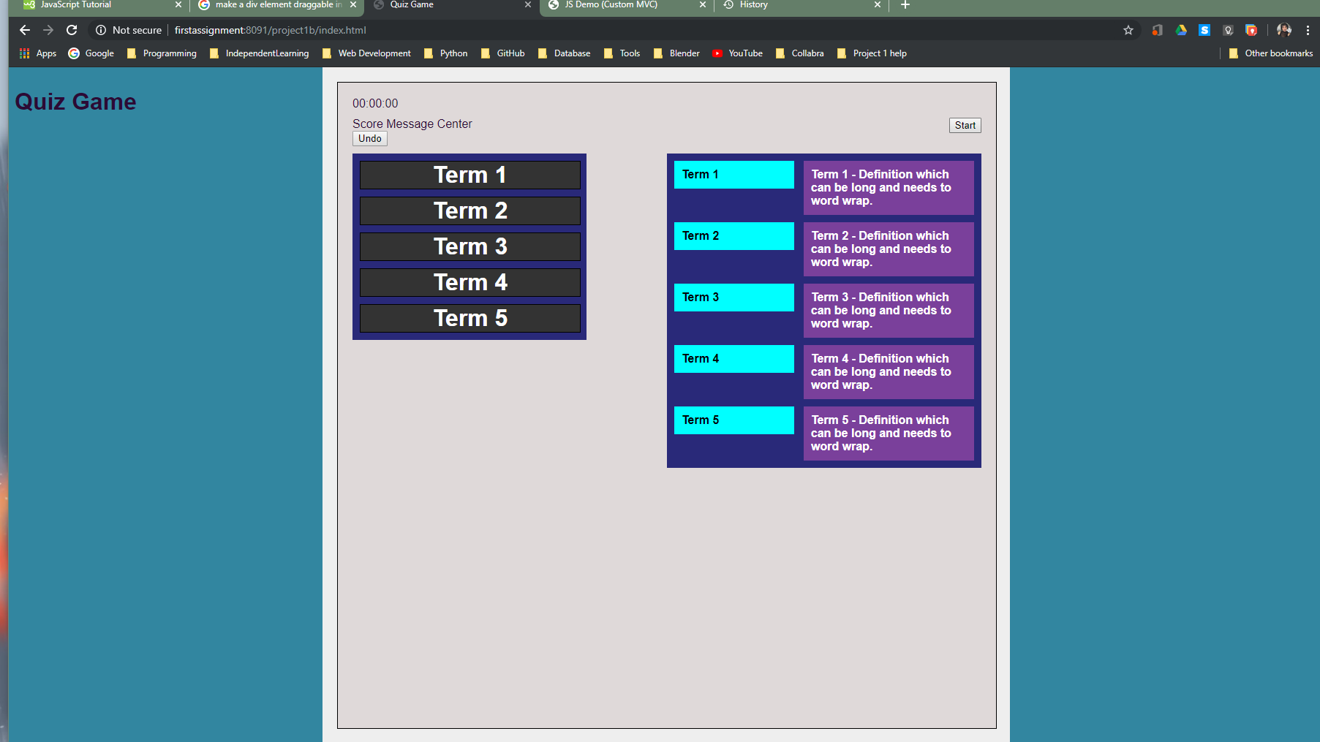

I was not able to accomplish the goals of this exercise.

Since I did not complete this assignment, I was not able to move to the optional assignment.

**Resources:**

I relied heavily on W3Schools (<https://www.w3schools.com/>) for all of the JavaScript and HTML tutorials.   
 I tried to build my timer from a YouTube video by David Yakolev found at: <https://www.youtube.com/watch?v=sUOQ9lLZq7A> <https://www.youtube.com/watch?v=iOdvkI6ZBqs>

Also, I relied heavily on Various Google searches.

**Future Considerations:**

* Break the Goals into separate parts and try to assemble them as a finished product
* Continue with this project until I finish it on my own.
* Practice more with Google’s Dev Tool. I needed this more than anything but I only had a small understanding of how to use it.

**Conclusion:**

Despite my inability to complete this project, I learned a lot. I understand the need to know vanilla JavaScript and HTML and the role they play in Full-Stack Java development. I felt that with more experience, I could have done much more within the time constraint of this project. I completely believe that some of the issues I had with accomplishing this assignment was hindered by a software problem with my computer. Possibly because I have it dual booted with a Linux Distribution. I plan on backing up only the files and applications needed for this job and doing a clean install of Windows and reconfiguring XAMPP before the next assignment.